**Project Overview**

My Group project was the Titanic project. This was a project that was assigned to my group, the task was to use machine learning via Python to create a model that predicts which passengers would survive the Titanic shipwreck.

**Success and Failure related to the final submission.**

Overall, as a team I think my team performed solid in relation to the final submission. I feel like, as a team we came together a lot stronger when it came to the presentations and team-report/any other final submissions, we were all able to be transparent with what our problems were. For example, if someone were struggling with their section on their team-report, that person would usually message in the groupchat on Discord and receive feedback the same day as to what to do next.

Furthermore, I feel like the presentation/final submission did go well. This is because different teammates in my team (who were not usually used to speaking) were able to come outside their comfort zone and be able to answer some of the questions to the Academic and others such as the General Lecturers Assistants.

**Difficulties Related to the Project:**

A difficulty I encountered within the Titanic project is improving the performance of the machine learning model to its fullest. For instance, despite me having my code ready to present to the General Lecturing Assistants and be used in our presentation/team-report, it would have been even more advantageous, if I did a bit more research in relation to machine learning algorithms. Personally, I feel like this slightly inhibited the fullest potential of the machine learning model being developed.

Furthermore, in as much as our group performed well as a whole, there was a group failure. For example, we had one person in our group, who went inactive after our first meeting on Jira. This was a bit problematic, initially as when it came to delegating roles on the first session on Jira it made it complex in relation to who does what. Nonetheless, as a team we persevered and still managed to produce something of value.

**Project Management Review**

In relation to project management, as a team we took the initiative to learn about each other’s topics. We did this by ensuring, that when we first started, we did an icebreaker session (as a mini get to know session) on the 29th of January (organised and setup by Samati on Jira). See below:

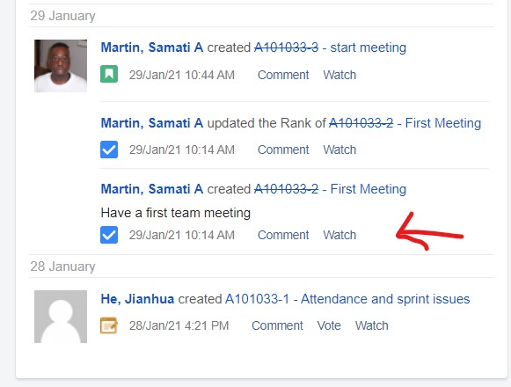

During the meeting on Zoom which Samati hosted, we discussed our strengths, weakness and ideal outcomes of the team project. Personally, I felt this was one of the pinnacle points of our team-project as it helped me identify who could speak to me, if they needed help with something they were trying for the first time such as help with making the presentation flow or who I can ask for help from, for assistance with understanding certain elements of the conclusion or Python the Titanic project itself to present to the General Lecturing Assistants and Academic later on in the team-project. This ended up being productive, as we were able form a groupchat on Discord following from this, where we discussed what we’re working on, motivating each other when any of us were feeling under the weather and helping each other if necessary.

***Personal Contribution***

***Design***

As the technical consultant of my team, I decided to take a note of how to improve the existing machine learning model by speaking to my teammates. More specifically, sending them the code, I was using. This allowed me to create a feedback loop between my teammates and myself. This was where, I had discovered on my current existing machine learning model, that the code did not include anything in relation to gender, which would have lowered its accuracy. Furthermore, in my design process, I also found out there was no algorithm for the missing values in the code via decision trees.

***Implementation/Testing***

So, I decided to take the initiative to do some research as to what machine learning algorithms could be used to solve the problem with relation to the missing passengers for missing values. After, doing some research, I found that [on this website](https://www.analyticsvidhya.com/blog/2017/09/common-machine-learning-algorithms/), I discovered that Random Forest algorithm would be the most adequate algorithm to solve my problem. The code that I used to solve this problem could be found below:

Ultimately, following from this I was able to test my Python code and was able to get the output that you see below which allowed the machine learning model to gain a higher level of representativeness in relation to which passengers would survive the shipwreck.

***Documentation***

After realising, that the machine learning algorithm, I used worked, I decided to keep a note of it in my notepad, to keep it aside in case I need it for a future project. In addition, I utilised my presentation and communication skills to present the Titanic project code to the General Lecturing Assistants. This allowed me to receive feedback on what I had programmed, and thus, enabling me to go back to Tomas Tazar (my colleague who was doing the machine learning improvements with me) and other team members on what else we could use to improve our current score.

***Secretarial***

In relation to what I did secretarial wise, I took the responsibility to host a group-call meeting via zoom for the presentation and team-report. See below:

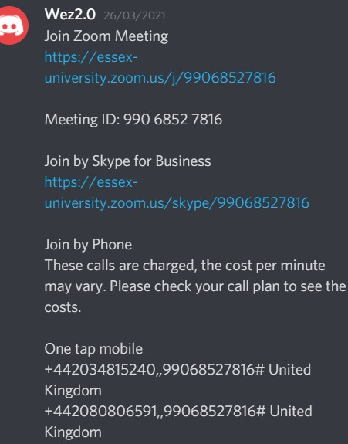

This was done to ensure that everyone was still productive and clear on the task at hand, as well as also making sure everyone is still motivated to complete the task in case anyone was feeling low or needed some individual timeout to recoup, gather their thoughts together again and execute.

***Others – Self-reflection***

***Individual for the project***

Upon reflection, I could have done a bit more. By this I mean, there was a point in time, where despite everyone working together on their respected tasks, I could have aided in explaining what the Python code for the titanic project does. So, that despite everyone having the fundamentals of it (from our Introductory to Programming Module, earlier last year) my teammates could have understood a bit more (not only for the team-project, but maybe for their possible future career in technology) as a supposed to just putting in comments in my code and assuming everyone understands what the comments mean.

***Individual for the team***

There are things I could have done to improve the performance within my team. That is in relation to utilisation of time. This means despite me having my code ready to present to the General Lecturing Assistants, it would have been even more beneficial, if I did a bit more research in relation to more machine learning algorithms.

***Key Lessons for Individual Project***

There are 2 key lessons I can take with me from the titanic project set to me, I can utilise during my individual project in the final year.

Firstly, doing more research as a suppose to research that is just about tangible for the team-project is always advantageous. For example, learning more about the team-project that was assigned to me. I feel this would be valuable for my final year project as it would allow me to transition into doing the project a lot more seamlessly.

Lastly, explaining everything. This is significant, because in my code there was a lot of technology jargon being applied. Thus, if I took extra time to use my communication and interpersonal skills to help clarify what my code means to my team-members verbally as a suppose to just throwing in comments. This would be largely favourable for me in my final year’s individual report, as when being asked it will help me to see bigger picture and, enjoy the task a lot more.

***Key Lessons for presentation***

If I had to design a presentation in the future, I would take 3 key lessons with me.

Firstly, conciseness and structure – being able, to streamline my presentation to just the relevant points only. Whilst, also noting (in my notepad and my mind) the context behind the parts I am not exactly 100% confident in. This would be valuable, as it will prevent me from overthinking what I am being asked to present and be able to directly answer what is being asked.

Secondly, audience engagement – asking the people(s) I am presenting to questions, get them involved and make it interactive. This would help me, because it will allow my presentation to flow as a conversation as a suppose to a script. Also, would allow me to develop a rapport with those I am presenting to.

Lastly, voice control – being able to use my vocal projection to emphasise certain parts that need to be highlighted within the presentation. It is all good, having a nice colourful, informative presentation. But, if it sounds like I am a robot or speaking monotone, then it might not sound energetic.